25. Simulation of Plane Strain (Shear Box)

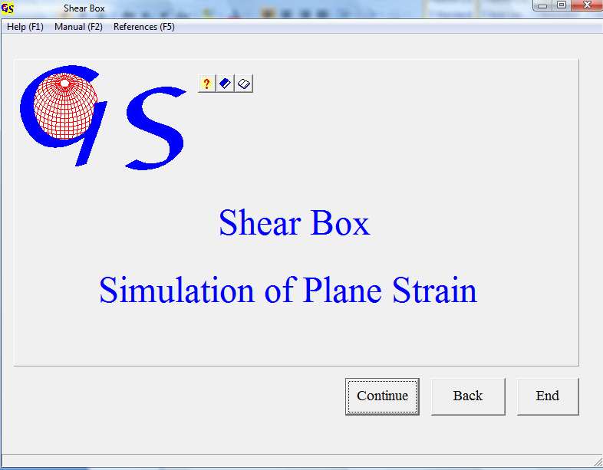
Fig. 1

This program (Fig. 1) simulates plane strain deformation (shearing and flattening) on various markers.

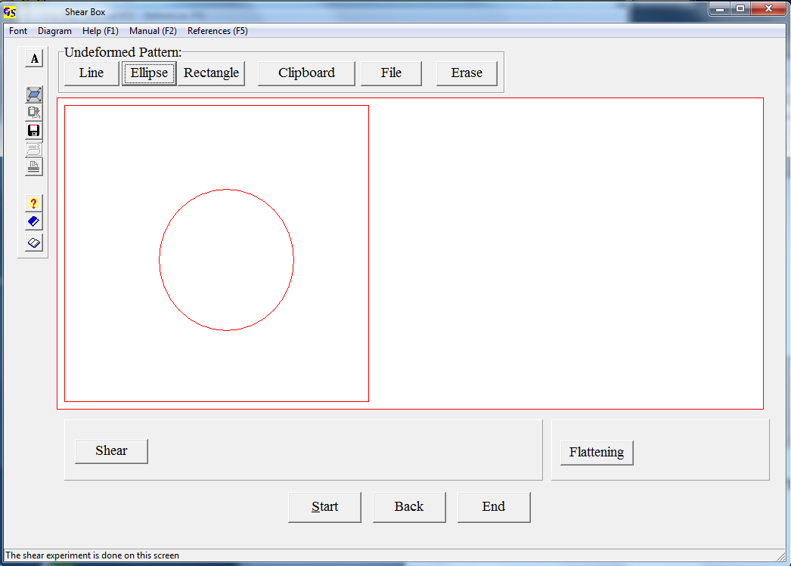
Fig. 2

In Fig. 2 a circle is drawn after clicking on the button "Ellipse".

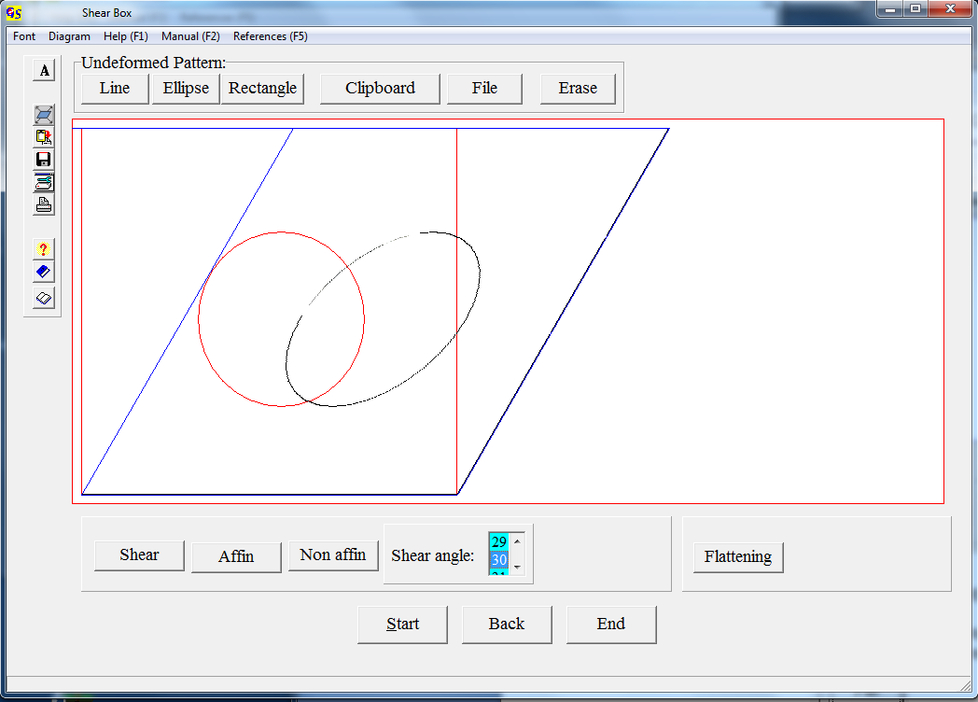
Fig. 3

Fig. 3 shows the deformation of this circle after clicking on “Shear“ and “affine“ and after selection of a shear angle of 30°.
Fig. 4 shows the deformation of a bitmap which was imported by clicking on the button “File” and selecting the file which contains the bitmap.
You may also use a bitmap from the clipboard.
The button “Erase” erases the input and the deformation.
Fig. 5 shows a non affine (inhomogenous) deformation of this bitmap. Shear strain increases to the upper margin, controlled by a factor (Fig. 6).

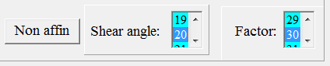
Fig. 6

Fig 7 shows flattening strain with shortening in vertical direction to 70% of the original.

The options of the menu "Diagram" are explained in program 3.

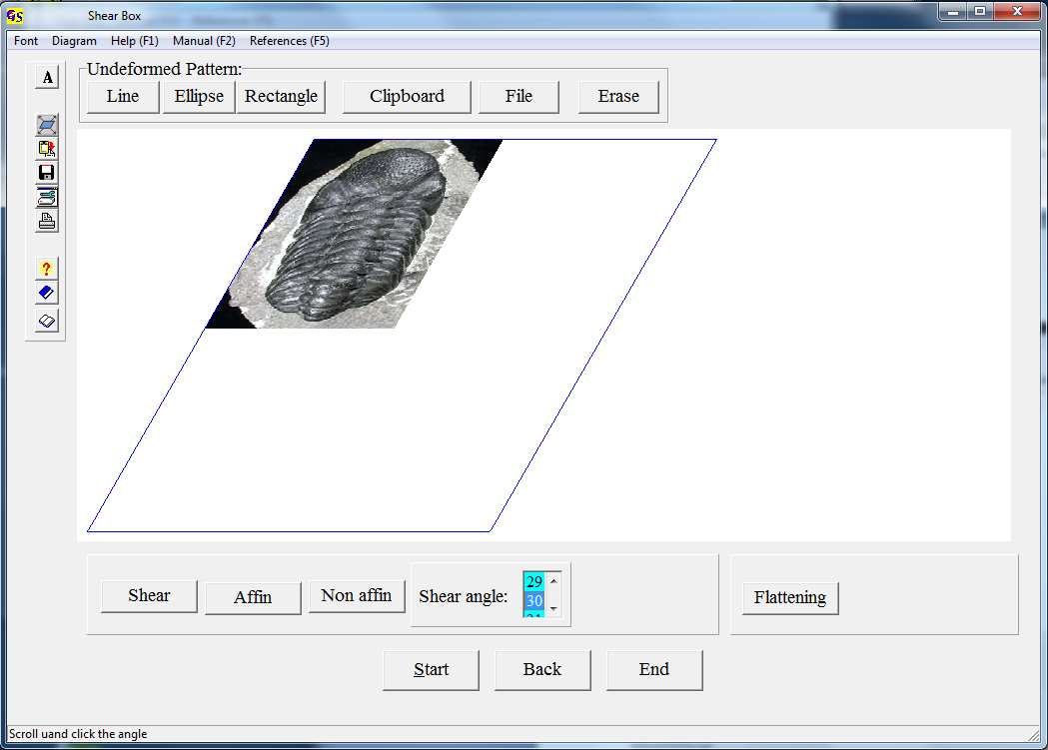
Fig. 4

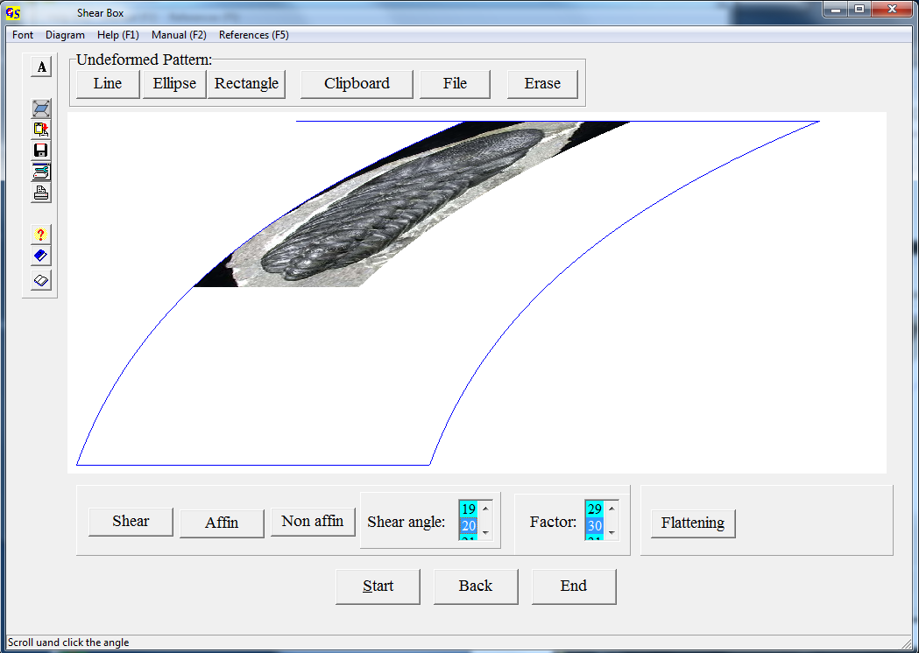
Fig. 5

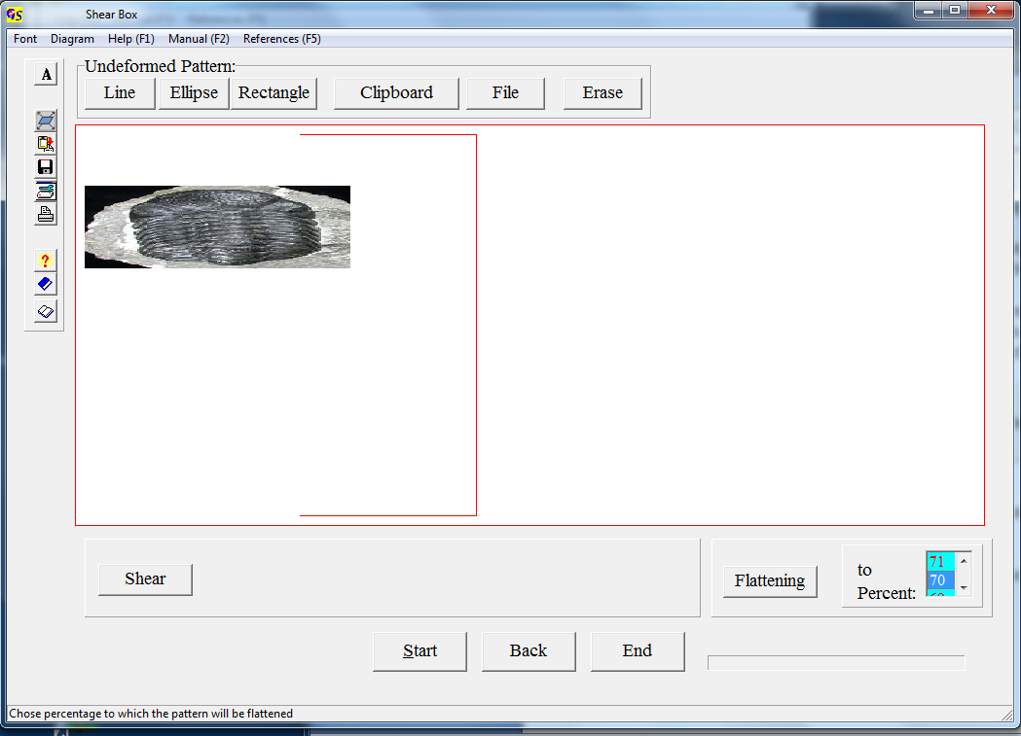
Fig. 7

